Donor Tree Campaign – Yes, I want to join!
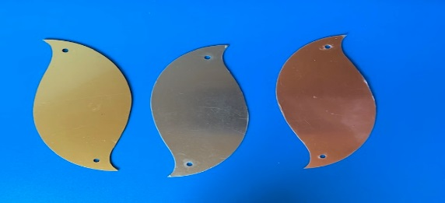
To acknowledge your gift, the donor tree will display 300 leaves in gold, bronze and silver. Leaves are approximately 3” x 4”. Each leaf will be personalized up to 4 lines, 24 characters per line.
☐ Gold Leaf: $1000
☐ Silver Leaf: $500
☐ Bronze Leaf: $100
Personalization – 26 maximum characters per line; including punctuation and blank spaces. Please print clearly.
Line 1 | Click or tap here to enter text.
Line 2 | Click or tap here to enter text.
Line 3 | Click or tap here to enter text.
Line 4 | Click or tap here to enter text.
Name: Click or tap here to enter text.
Address: Click or tap here to enter text.
Phone: Click or tap here to enter text.
Email: Click or tap here to enter text.
Total Amount: Click or tap here to enter text.
Payment Method: (check one)
☐ Check or Money Order (Made payable to Disability Network Capital Area)
☐ PayPal ☐ Master Card ☐ Visa
Card # Click or tap here to enter text. Exp Date Click or tap here to enter text. CW Number Click or tap here to enter text.
Name on CardClick or tap here to enter text.
Billing Address (if different from the above mailing address)
Click or tap here to enter text.
Mailing Address: 901 E Mt Hope Ave, Lansing, Michigan 48910
Main: 517-999-2760 Fax: 517-999-2760
Email Address: lparker@dncap.org

